**PAPER**

**Abstract**

Current crowd simulation research could achieve path planning for collision avoidance, previous researchers are more focus on develop walking behavior of single or pair agents. Unfortunately, the previous crowd simulation approaches are lack of realism and flexibility because they did not involve complex interaction such as allowing agents to queue up to form lines and then move in and out from different lines based on agent’s desire. In order to create realistic and trustworthy crowd simulation result, we proposed new, sophisticated crowd simulation algorithm that allows agents to achieve complex features. The implementations were obtained from data collections and direct observations from video records in real-life events. Simply implement agents pair walking feature is not enough to achieve the natural behavior. In our approach, agents in the scene could queue up to form waiting lines in the scene and pass through gates one by one. What’s more, based on the certain external factors, agents make decision about switching between lines if they find out there has a shorter line to queue up. Our algorithm could process more then 250 agents and successfully achieve realistic queue up behavior.

Keywords: Crowd Simulation. Queue up Behavior. Pair Walking. Re-Consider Behavior.

**Introduction**

[Previous work] The increasing proportion of people living in urban areas brings new challenges to urban planning and architecture. Bringing a large amount of people to perform the crowd experiment is unmanageable and dangerous. Thus, crowd simulation plays an important role in addressing these challenges. With the help of crowd simulation techniques, urban designers and architects could determine the evacuation time of a massive crowd, detect the behavior of crowd flow inside of a building or prevent overcrowding during certain events. What’s more, crowd simulation is also frequently used to generate virtual scene for visual media such as films or video games.

Social behaviors and movements of crowd within a limit environment have been of interest for years, previous study about interaction and walking mode of crowd are constantly studied. However, recent researchers’ approaches are still inflexible: they lack of dynamic queue up behavior that involves re-consider behavior based on agent’s desire, they do not include complex social behavior when agents are within certain condition in the environment, or they do not consider how crowd avoid chaos by achieving certain behavior patterns.

[Contribution]

**Our contributions:**

A large crowd of people is a complicated system. Our contribution is designing an algorithm that could implement in agent-based modeling to simulate the behaviors comprised of agents have pair walking, queue-up behaviors, decision making and security gates passing. Agents could behave as walking pedestrians in real life. Sine agents could be in pair relationship, certain rows of the waiting lines could have more than one agent.

We evaluate the realistic, dynamic and natural result of crowd simulation by measuring different key features the real-life crowd have. In our approach, agents in the simulation will interact with other agents by pair walking, queuing up, forming waiting line, switching between lines and passing through security check. The simulation will run with more than 250 agents at a time.

**Related Work** (Previous Works)

Agent based simulated approach [Baig, Mirza Waqar] designs agent as ellipses that have a sense of the environment and plan their own path ahead of time to avoid agent collisions. Unfortunately, the output of simulation is still lack of realism and flexibility. Since it does not involve complex behaviors such as allowing agents to move in and out of different groups or queues based on agents’ desire. Agents planned a path ahead of time without making justification might end up a situation such as an unnatural long waiting line in the scene where several shorter lines exist. However, in reality, people do not just stay in their waiting line once they choose it, they might need to change waiting lines if there is a better option.

What’s more, many existing approaches have achieved more complicated behaviors; crowd dynamics and behaviors could be various based upon the environmental limitation and requirements. Julio Godoy [Julio Godoy] provided dynamic agent base approach that agents in the scene could have independent decisions and distinct goals to plan their own movements and collision avoidance behavior. After agents learned optimal strategies in the given simulated environment, interactions among each agent can be more “polite” and natural. Carmine [Carmine] extended state-of-art predictive approach with the social awareness, prediction and social collision avoidance to achieve the prediction in social path following behavior. Social awareness could improve the realism, it is a signal that indicates agents are approaching each other. After agents receive the signal, they adjust their own behavior or direction for the future social interaction. Repulsive forces and given priority of agents are involved in simulating the social interactions. In order to simulate social interactions among agents in the crowd, Walk Along Steering [Walk Along Steering] developed the Walk Along Steering allows agents in small group have six social steering behaviors that makes agents’ movement and reaction smoothly and naturally. Based on three-layer architecture controlling motion of IVAs designed by [Reynolds], agents could achieve patterns like following, avoidance, waiting and approaching. To allow the crowd has more dynamic social behaviors, sai-keung’s [sai-keung] approach presents a crowd simulation that involves behaviors that agents are more interactive. In the simulation, two or more agents are required to perform actions simultaneously to finish certain tasks, agents are divided into two categories: workers and pedestrians. Complex tasks can be assigned to worker agents, workers will cooperate with each other and create complicated behaviors by decomposing a complex task into numbers of simple task.

What’s more, many existing approaches have achieved the complicated behaviors. Crowd dynamics and behaviors could be various based upon the environmental limitation and requirements. Julio Godoy [Godoy, Julio, et al.] provided dynamic agent base approach that agents in the scene could have distinct goals to plan their own movements and collision avoidance ability. Interactions among each agent are being “polite” and natural after agents learned optimal strategy in the given simulated environment. Carmine [Carmine] extended state-of-art predictive approach with the social awareness, prediction and social collision avoidance, this approach achieved the plan ahead in social path following behavior. Social awareness is signaling agents that they are approaching to each other. Agents should adjust its behavior and direction for the future social interaction. In order to simulate social interactions among agents in the crowd, Walk Along Steering [Walk Along Steering] developed the Walk Along Steering allows agents in small group have six social steering behaviors which make agents have smoothly movement and reactions. Based on three-layer architecture controlling motion of IVAs designed by Reynolds [Reynolds], agents could achieve patterns like following, avoidance, waiting and approaching. To allow the crowds have more dynamic social behaviors, sai-keung’s [sai-keung] approach presented a crowd simulation that involves behaviors make agents more interactive and dynamic. In the simulation, two or more agents are required to perform actions simultaneously to finish certain tasks, agents are divided into two categories: workers and pedestrians. Tasks can be assigned to worker agents; workers will cooperate with each other and create complicated behaviors by decomposing a complex task into numbers of simple tasks.

**Video Analysis**

We record crowd at CenturyLink on different entrances during events such as concert and Disney Ice Event to study how people gather, walk, form waiting lines and passing security processes. We collected and analyzed common behavior features that crowd might have and implemented those data into every aspect of our application:

* Pair walking.
* Queue up behavior.
* Form waiting lines.
* People switch to shorter a shorter line.
* People move forward until have space between security gate lines.

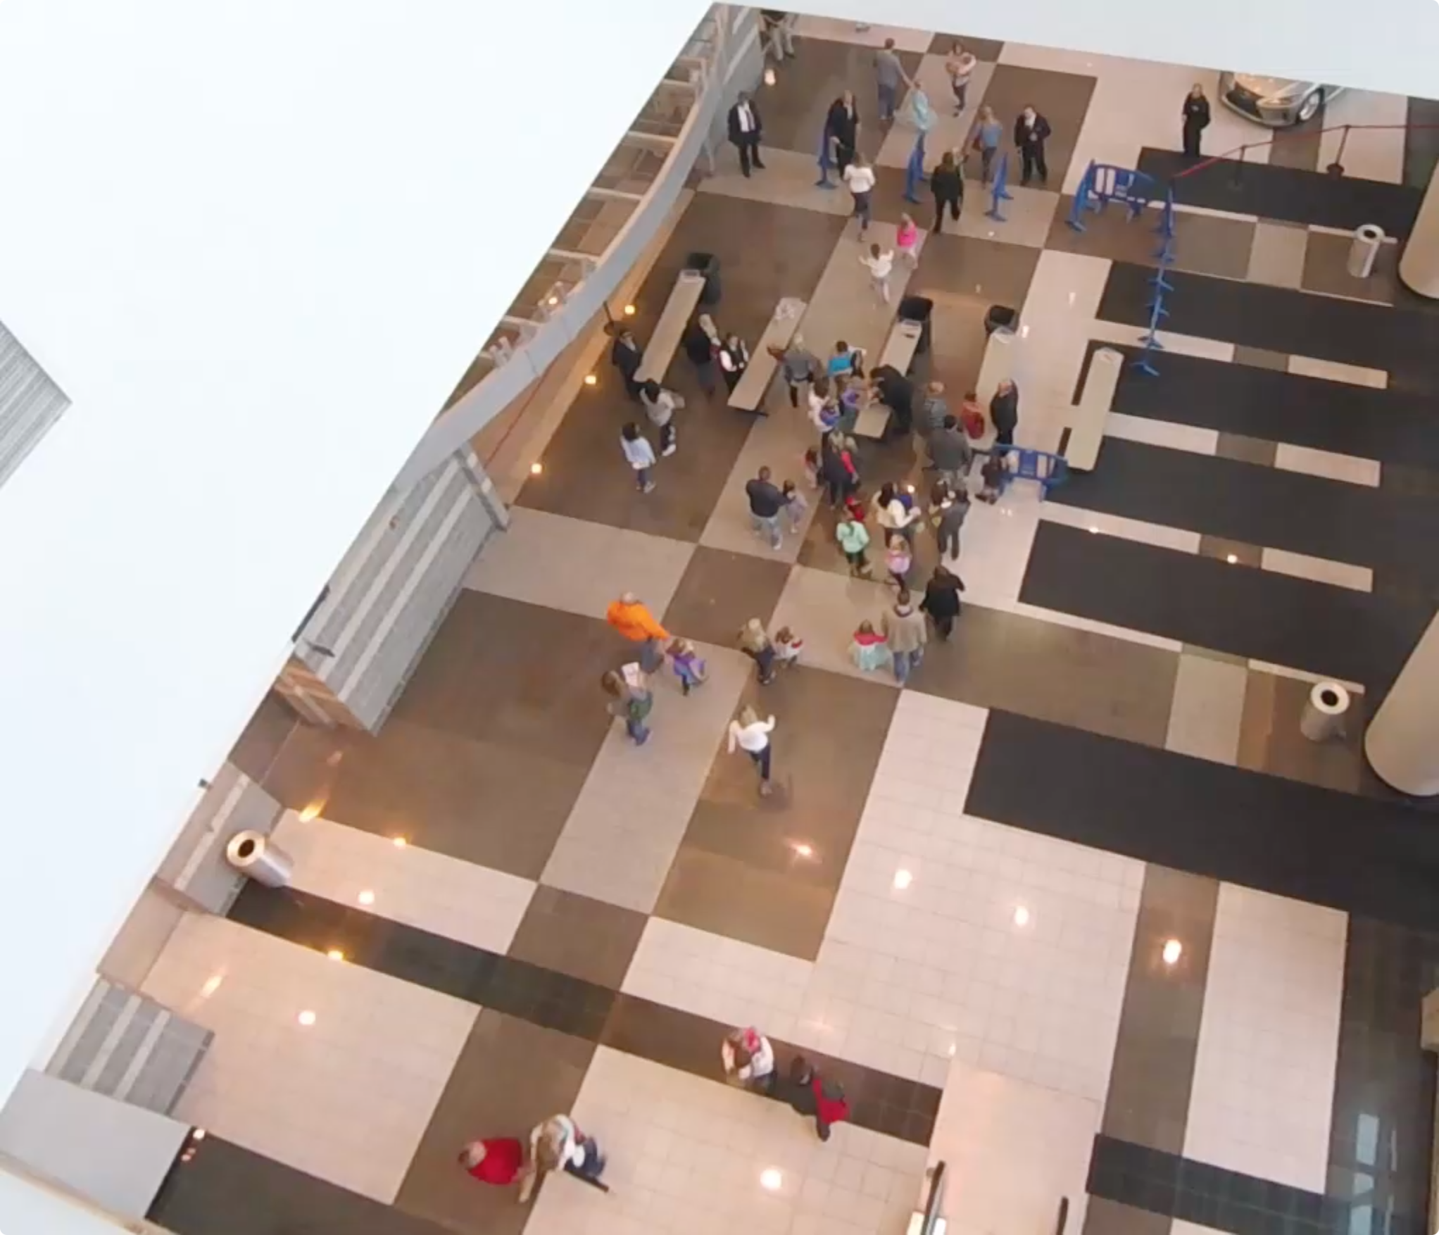

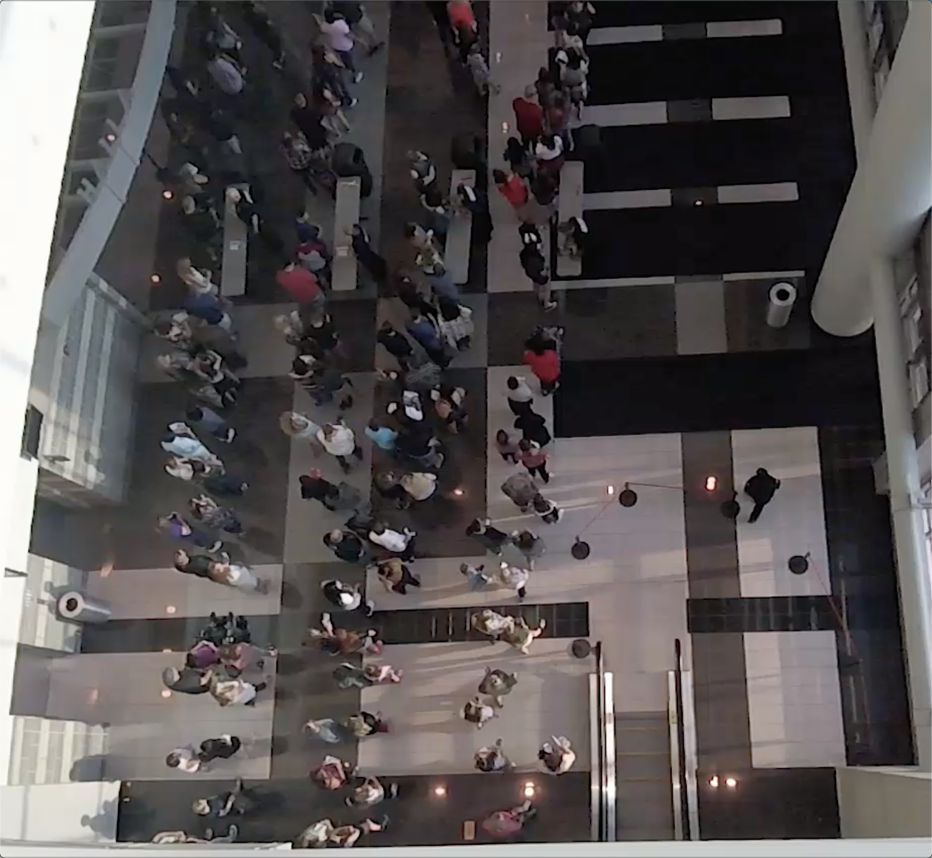

**1. Pair Walking Behavior:**

Based on the video, the majority of people attend events with their friends or family members. Thus, when the crowd is moving, they are divided into various small groups. Because people in the group could have conversation with each other while they are walking, so the ongoing people are more likely to maintain the side by side status. The maintenance of the group is dynamic and self-adjusted. If one of the people in the group is left behind, people in front will slow down until stop to wait for their friend until he/she catches up, or if people realize themselves are left behind by their partner, they will speed up to catch up to maintain the group walking. As what we observed from these videos, the pair/group walking behaviors happen almost among every people in the scene. For example, people who finished the security check will stand at somewhere in front and wait for his/her partner. In our approach, in order to simplify the group structure in the simulation, the maximum number of agents in group is set to 2. We also divide agents into two roles: one is in leader role, the other is the follower role. Both agents are facing the same direction, each agent will adjust its speed to maintain the pair walk behavior as we just mentioned above.

**2. Queue-up Behavior:**

In the video, a large amount of people gathers in front of the gates did not create a chaotic crowd. They are orderly forming waiting lines. When waiting lines were formed, the upcoming people also orderly queue up and expand the length lines. People in waiting lines slowly moving forward while people at head of lines pass the security checks. Because we have observed the crowd is divided into small groups, we will consider each group as a unit when they do queue up behavior. Thus, these groups could form waiting lines that each row has one or two people (not every people in the group). What’s more, line switching behavior also frequently happened among waiting lines. Waiting lines have different length, we found out people in the long waiting line will change to the shorter line if they have spotted another shorter line or empty gates nearby. Not only the people in line do switch behavior, the upcoming people will also change its direction to walk to the other line if a better option has found. However, we found out not all people in a rush to pass all security processes. In the videos, we observed there are small number of people are less interested in moving to the shorter line, they prefer staying at their original line.

**3. Pass Security Check Behavior:**

Every people in the videos has to finish two sequential security processes before entering the building. For the first process, people need to stop at the gate to let the security faculties check their ticket and bag (if people carry bag to the event). Therefore, in the first gate line, the checking process of people who only bring the ticket is relatively faster. They only need to show the ticket to faculties and then they could directly pass through the first gate. For people who carries bag, security faculties in the first gate line need to closely look inside people’s bag. Thus, they need to spend more time on the first gate line. For the second process, security faculties used the handheld body scanner to scan people one by one. Because everyone takes the similar process, the time people cost in the second gate line are more consistent.

Based on the video, space between two gate lines is limited. If the number of people passed the first gate line is large enough, the space between gate lines is easily get full. When the room is full, even though people have finished the first checking process, they need to stay at the first gate lines and wait.

**Approach Environment Intro**

Before dive into our approach, we need to finish our simulation environment setup: agents in the scene could achieve features such as interaction, navigation, perception and optimization; in the simulation, the virtual two-dimensional plane agents walking represents the environment; timer on the left top indicates the simulating time, for each 4 million seconds a new velocity vector is calculated and each frame agents next position is updated. Our approach utilized the work of an open source state of art navigation mesh construction toolset as a foundation architecture, the open source application provides fundamental static and dynamic obstacles avoidance features. We expand this open source by increasing social behavior, pair walking, complex queue up behavior, waiting lines switching behavior and orderly pass through security checking gates.

Scenario

Individual agents or pair agents are randomly generated from the virtual entrance; each agent is initialized with a default start position and end position, and they will walk from start to end position. However, before agents reach their destination, every agent has to finish two security checks. Every agent stops near the security checking gate to simulate the security check in real life. Since the new agents are continually generating and every agent needs to spend a few seconds on the security processes, the number of agents in the scene will increase dramatically and the crowd form. However, instead of generating a massive chaotic crowd, agents in the crowd will queue up orderly and form numbers of waiting lines. Each agent in line will do the security check one by one. After finishing the security check, agents will move to their default end position and depart.

Implementation: Initialization

Achieving the complicated crowd behavior features requires various initializations. Based on the real-life videos we recorded during events and scenario we have mentioned, agents have to behave series of complicated behaviors. They need to finish checking processes before entering the building while they are having social interactions with each other. Thus, simply generating agents in the scene is not enough. At the beginning of the simulation, we need to initialize environmental factors based on the input data. Image on the below is the mockup demo that illustrates the agents and environment.

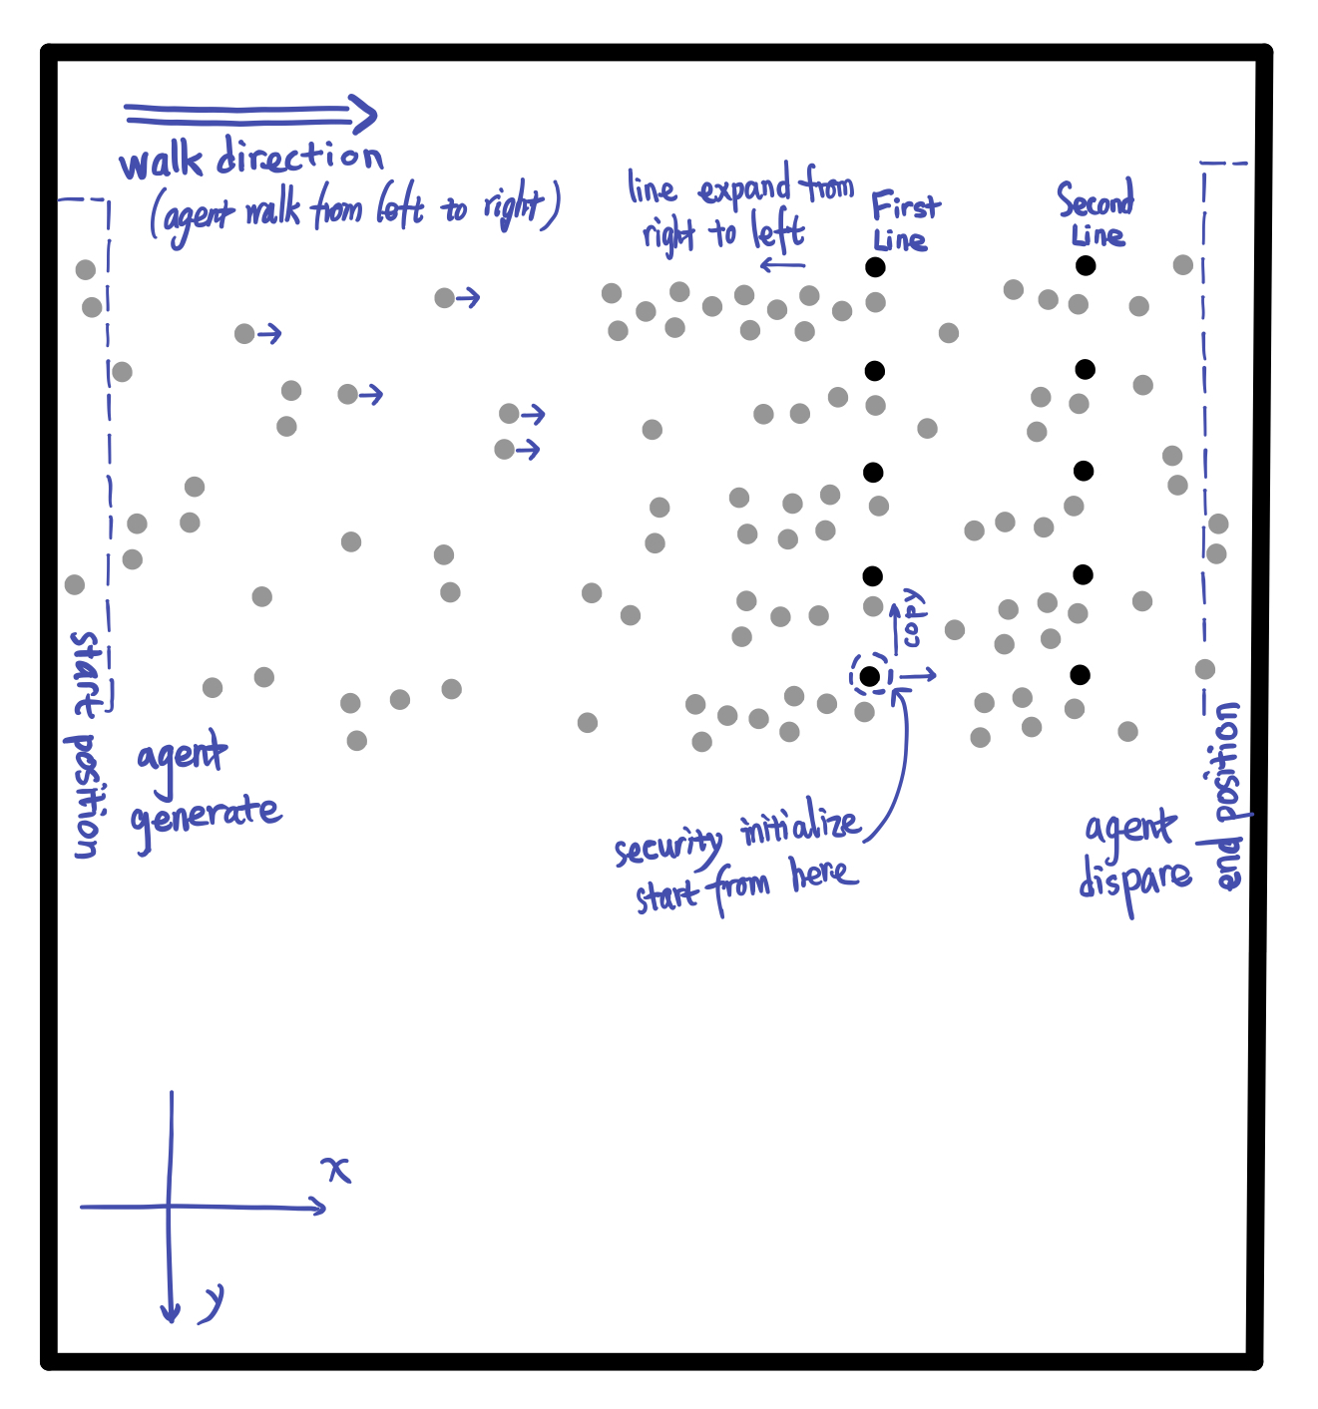

Descriptions below are introduction of the initialization processes of the environment and default states of all agents:

* **Gates Initialization** – Agents need to pass through the security gate before entering the building. In this scene, we created 10 checking gates and divided those gates into two gate lines. Beside each gate, we allocated faculty agent to represent security faculty as we observed in videos. During the simulation, all security faculties stand next to its own security gate.
* **Agents Check Time Initialization** – Agents have different security checking time. In real-life video, before entering the building, people have to stop at first checking gate line to show their ticket and stop at the second gate line to do security body scanning. In the simulation, each agent is randomly assigned two values to represent the amount of times each agent needs to take to finish the checking processes. For the value that represents ticket/bag checking time, because the number of people carry bag is relatively smaller than the number of people who don’t, the initialization of agents’ first gate checking time must achieve the corresponding pattern. The number of agents that required to take longer time staying at the first gate line is in small proportion and they are randomly distributed in the crowd. Since each agent does the same checking process, the value that represents the second gate checking time among each agent will be relatively consistent.
* **Agents Gate Option Initialization** – Agents always choose the shortest path. In this simulation, agents are randomly generated on the one side of the scene, then each agent calculates the distance between each gate and chooses the shortest one to go.
* **Agents Relationship Initialization** – Agents in pair relationship have pair walking behavior. In this simulation, every agent is whether in individual status or pair status. Based on the input data of every agent, we will pair up at most two agents that have the close enter time, start position and end position. Agents in pair relationship play different role, one agent is leader, another one is follower. For individual agent, they are neither leader nor follower.
* **Agents Anxiety Initialization** – Agents make line switching decision based on level of their internal anxiety. In real life, people at tail of a waiting line who are not satisfied with the length of the line have high property to search around to seek opportunity to switch to the other shorter line. To achieve this behavior feature, we allow each agent to have emotion: anxiety. Certain level of anxiety degree is randomly assigned to each agent. In certain interval, the anxiety degree updates based on the agent’s current position in waiting line. Agents are more likely to change waiting line with high anxiety degree-.

In order to create a realistic crowd, we intensively control the flow of crowd to let it follows certain pattern. At the beginning of the simulation, the number of agents is relatively small, but when the simulation continues, the number of agents appear in the scene start to increase and finally reaches the peak. After that, the number of upcoming agents start to slowly decrease. This specific pattern of the crowd appearance allows us to see various crowd behaviors. At the beginning, since the number of agents is relatively small, we could see agents could orderly pass through the security gates one by one without waiting. Appearance of interaction between each pair/individual agent is relatively low. When the volume of crowd increases, the interactions among the upcoming agents start to increasingly happen, thereby resulting in large number of agents start to queue. At the end, number of agents start to decrease.

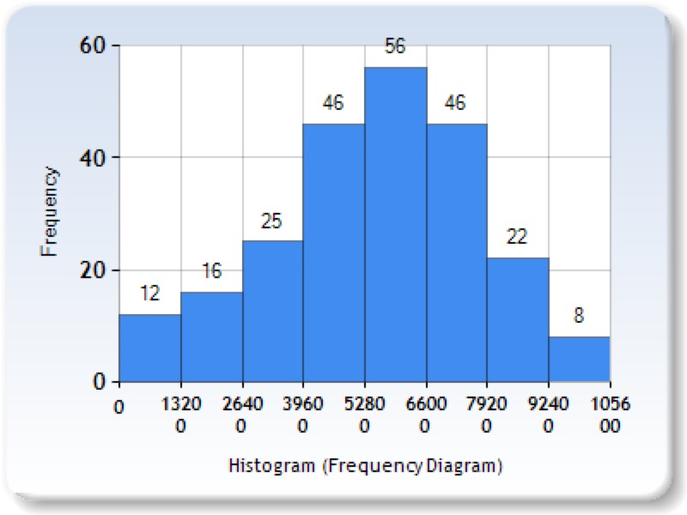

Charts above could illustrate the number of new agents walk in the scene in every 1320 million seconds. Each bar table shows the number of upcoming agents during the simulation, the flow of agents is following the bell-shaped curve. During time range from 5280 to 6600 million seconds, the number of upcoming agents reaches peak.

Implementation: Queue up Behavior

Form waiting line

Queue up Sate Diagram:

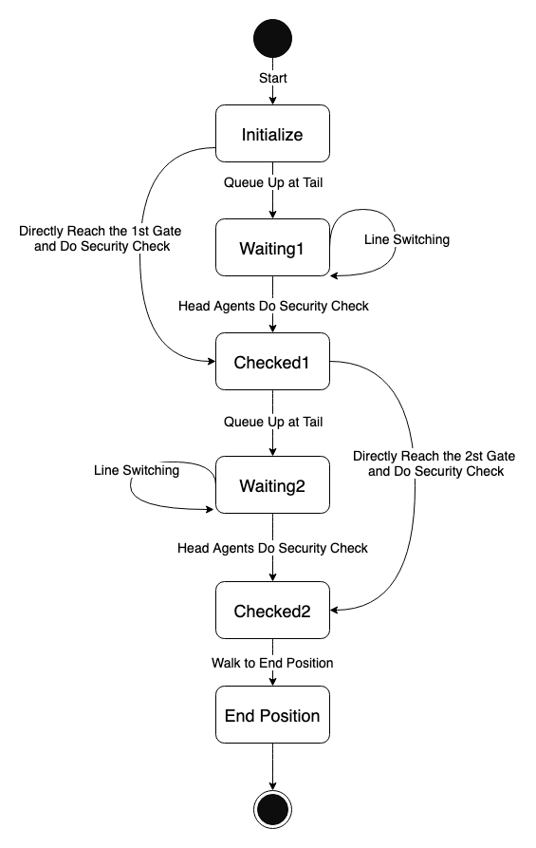

In order to enter the event, people need to do security check, so they will stop at security gate for a few seconds. However, because the upcoming people are continue moving to security gates, people who wait behind will form waiting lines. To simulate this queue up behavior, we allow each agent to have the following status:

* isWalking – agent is walking.
* isWaiting – agent lined up.
* isChecked – agent finished security check.

These 3 states help determine behavior of the agents. When agent is in isWalking state, agent is either walking to the gate/line or walking to the end position. Once agent lines up or for specific agent who could directly reach the empty gate, agent immediately set to isWaiting state. If the agent is leader, then the state of its follower is automatically set to isWaiting. For agent who is in isWaiting state, they are either waiting after certain agent or doing security check. In this case, we design a queue maintenance function to handle each agent in the queue.

Inside the queue maintenance function, in order to let agents maintain the queue, we let each agent in waiting line temporally set the back position of agent in front as its current destination. For agent who is head of the waiting line, it will start count the internal checking time. Once the value of checking time is 0, agent finishes the security checking and continue moving forward to the next destination. Since each agent’s value of time checking is different, we will see different agent take different time to finish checking. Then agent behind it will replace the head position and start the checking process.

When agent finished check, its state will change isChecked.

Because agents in pair relationship will walk in pair, they might still stay side by side even after queuing up. Thus, inside the waiting line, conditions between agents could have the following statuses:

* . . – individual agent queues up behind another individual agent.
* . : – individual agent queues up behind pair agents.
* : . – pair agents queue up behind individual agent.
* : : – pair agents queue up behind another pair agents.

As we mentioned above, follower agent is set to stay next to its leader agent. Thus, in the waiting line, unlike the other agents that their current destination is set as back position of agent in front, the follower agents’ current destination is set as left/right side of its leader. Then when individual agent queues up behind pair agents, it will set its current destination to middle back position of the pair agents.

Re-consider Behavior

Once agent enters the scene, each agent is assigned a value represents its anxiety level. From real-life video we record, we find out people will switch to other waiting line if they have a better option. However, instead of switching line, we also find out there are certain numbers of agents prefer to stay in their own line. Thus, we assign anxiety to each agent to simulate how agents make the switch line decision.

Assigning anxiety level to agents are not enough to simulate the reconsider behavior, we also have anxiety monitor to adjust the anxiety degree based on the waiting lines conditions. Agents based on the anxiety degree to make line changing decision: agent in higher anxiety is more likely to change line than the agents in low anxiety. Each agent has 4 level of anxiety degree. Anxiety degree update process follows 4 steps: (1) agent queue up in waiting line. (2) agent check the length of left and right side of current line. (3) based on the difference between the current line and other line, anxiety degree is correspondingly updated. (4) if agent is satisfied with its length of waiting line, agent’s anxiety degree decreases or remains. If agent is not satisfied with the length of its waiting line, agent increase the anxiety degree.

Once agent’s anxiety degree reaches the maximum value and there is a shorter line on left or right side, agent will leave its current waiting line and move to the new line. For individual agent, it will move by itself. For pair agents, both agents will leave and move together. After queuing up in the new line, all agents’ anxiety will set to 1, which is the lowest degree.

Implementation: Pair Walk Behavior

In the real-life video, people in group are talking to each other while they are walking, so they need to stay side by side and sometimes they need to slightly adjust their speed to stay in pair. In order to achieve the natural pair walking pattern, we let agents in pair to be follower or leader. Leader is the one leads them to their common destination; follower always adjust its speed to catch up its leader. However, not only change speed of follower, we also allow leader to adjust its speed to wait or catch its follower. For example, in the simulation, if the leader finished security check, instead of directly moving to the next destination, leader will stop somewhere behind the gate and wait until its follower finish the check.

How to Achieve Pair Walking?

In order to adjust follower’s moving speed, we need to keep track of angle of two vectors: one is from leader’s current position to leader’s current destination. Another one is from leader’s current position to its follower’s current position. After implement low of cosines and these two vectors, we could get angle between these vectors.

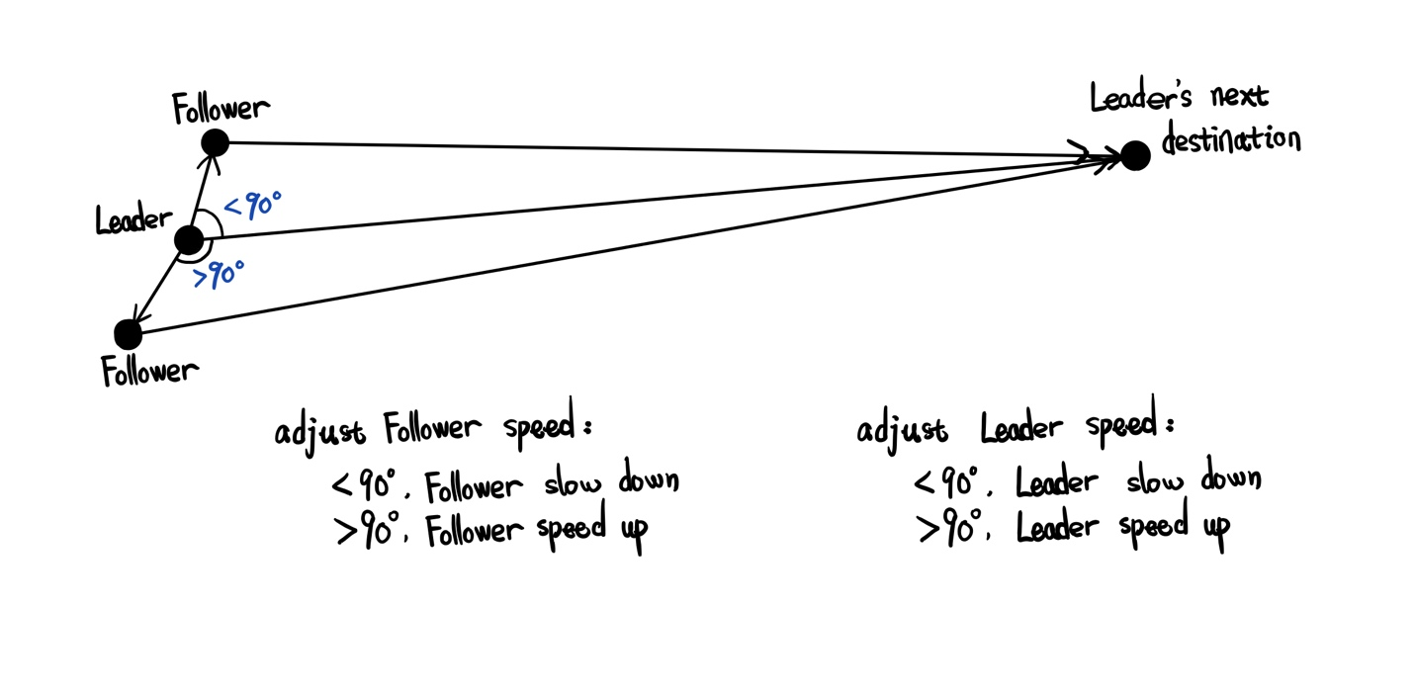

Bases on the value of angle, we allow agent’s speed has three states:

Angle is 90: the follower is exactly left or right side of the its leader. The follower agent doesn’t need to change it’s moving speed.

When the angle is less than 90, it means the follower is in front of its leader, the follower starts to slow down.

When the angle is larger than 90, it means the follower is left behind by its leader, the follower starts to speed up.

However, knowing the angle between two vectors is not enough to create the natural speed adjustment. In the simulation, we use a simple curve equation to help us deal with this problem. [这里需要考证一下Suppose A is the angle between these two vectors, then we know the range of cos(A) is [-1, 1], and the base is x axis. Thus, from two charts below, we could know from range while x is between -1 and 1, y value is between 0 to.]

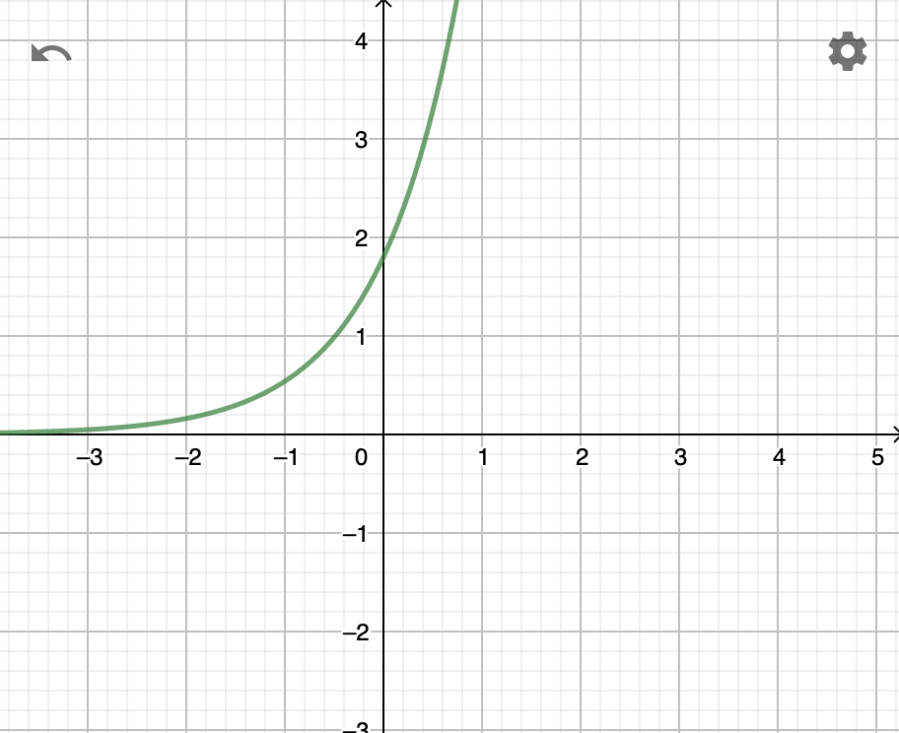 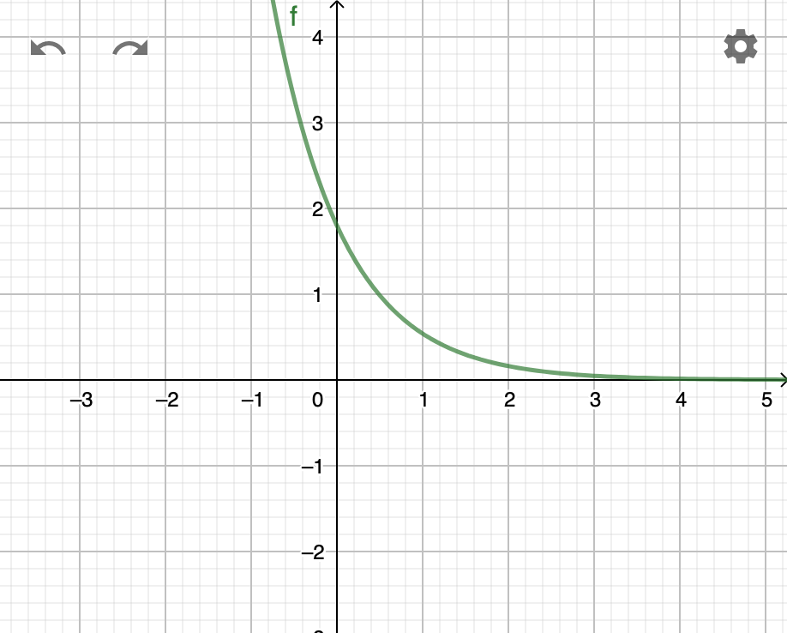

f(x)=1.8*0.3^(-x) f(x)=1.8*0.3^(x)

Reference:

[Baig, Mirza Waqar] Baig, Mirza Waqar, et al. "Realistic modeling of agents in crowd simulations." 2014 5th International Conference on Intelligent Systems, Modelling and Simulation. IEEE, 2014.

[Reynolds] Reynolds, C.: Steering behaviors for autonomous characters. In: GDC, pp.763–782(1999)

[Carmine] Oliva, Carmine, and Hannes Högni Vilhjálmsson. "Prediction in social path following." Proceedings of the seventh international conference on motion in games. ACM, 2014.

[Walk Along Steering] Popelová, M., Bída, M., Brom, C., Gemrot, J., & Tomek, J. (2011, November). When a couple goes together: walk along steering. In International Conference on Motion in Games (pp. 278-289). Springer, Berlin, Heidelberg.

[sai-keung] Wong, Sai-Keung, Yi-Hung Chou, and Hsiang-Yu Yang. "A framework for simulating agent-based cooperative tasks in crowd simulation." Proceedings of the ACM SIGGRAPH Symposium on Interactive 3D Graphics and Games. ACM, 2018.

[Godoy, Julio] Godoy, Julio, et al. "Online learning for multi-agent local navigation." CAVE Workshop at AAMAS. sn, 2013.

[OPEN SOURCE] Ref: <http://masagroup.github.io/recastdetour/index.html>